**LAB # 9:**

**OBJECTIVE:” INTRODUCTION TO IMAGE PROCESSING”**

**Lab Tasks:**

Assignment 1: Apply Brightness.

* Load an image.
* Increase the brightness of the image.
* Display the original and augmented images.

**CODE:**

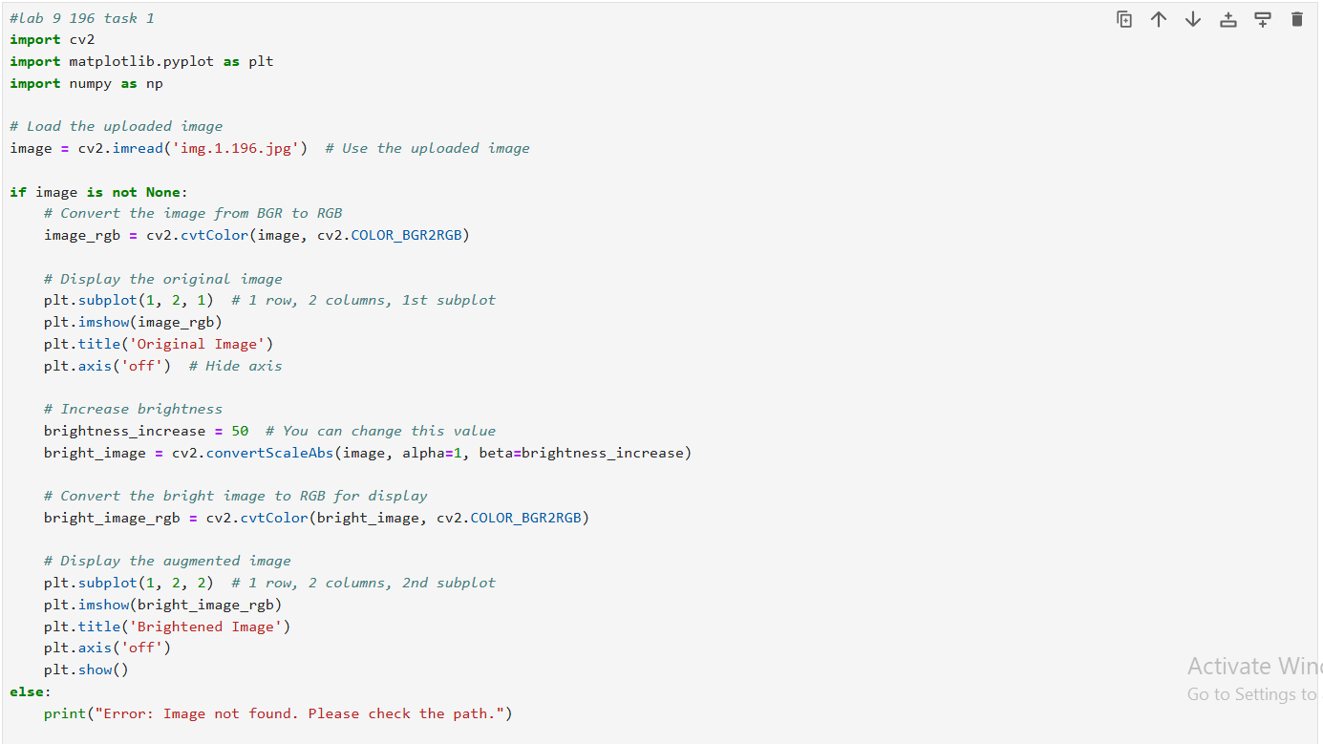

**OUTPUT:**

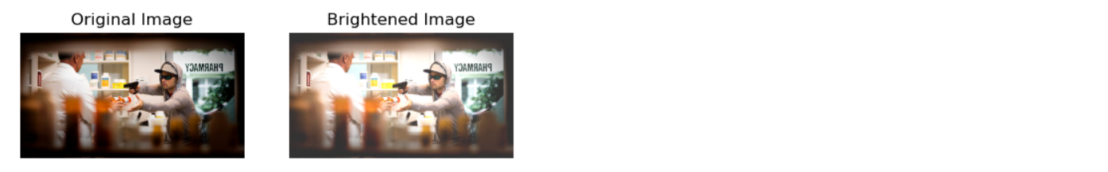

Assignment 2: Apply Another Edge Detection Technique.

* Load an image.
* Convert the image to grayscale.
* Apply the Sobel edge detection technique to the grayscale image.
* Display the original grayscale image and the Sobel edge-detected image.
* Hint: Use the cv2.Sobel function in OpenCV to apply the Sobel operator

**CODE:**

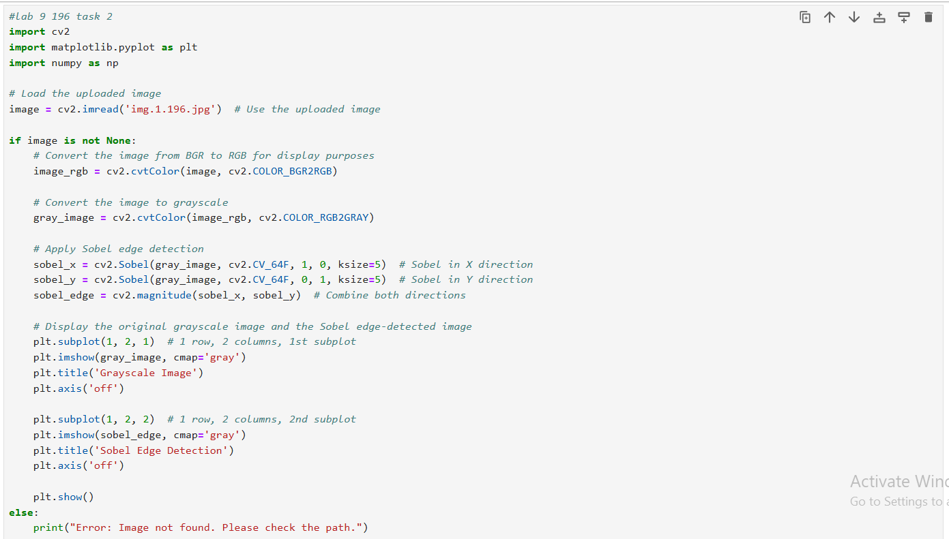

**OUTPUT:**

